Editing an existing quotation after a price change

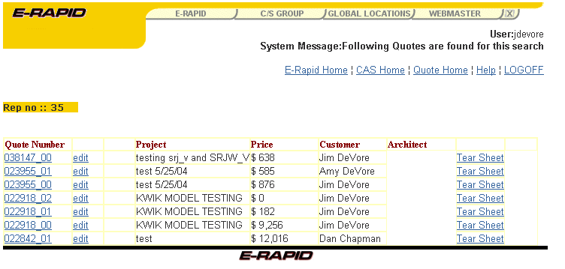
In order to maintain the current price level, it is necessary to click on the quote number.

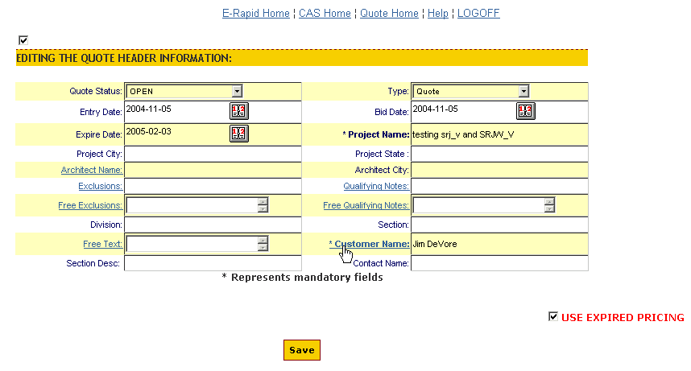
Once in the header, the USE EXPIRED PRICING box must be checked if you are holding pricing as quoted.

Note that all expired prices are maintained for ninety days only, at which time they will be converted to the “new” pricing.

From here, all other steps remain the same.

